**Q )Design a program for accepting decimal number divisible by 2.**

**INPUT(Odd number input) : -**

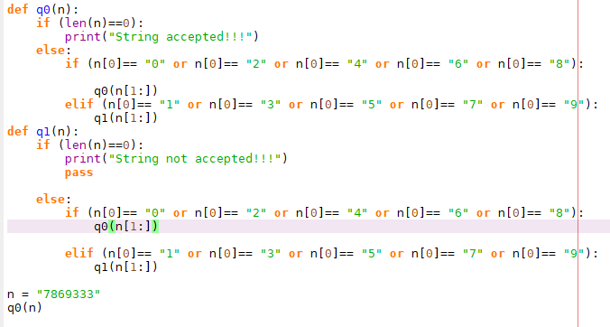

**OUTPUT : -**

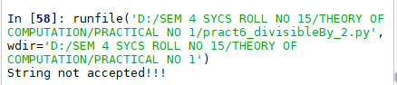

**INPUT (Even number input): -**

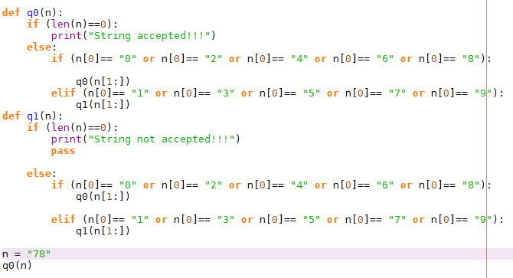

**OUTPUT : -**

